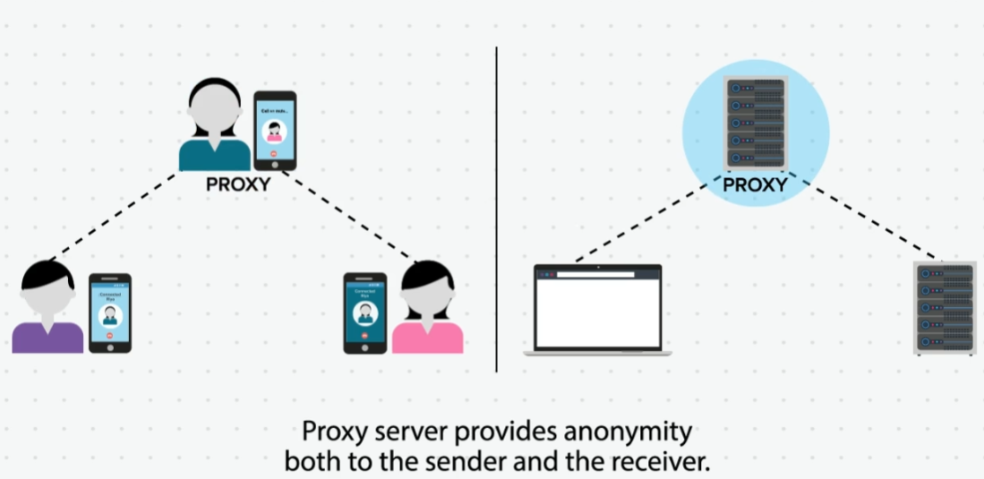

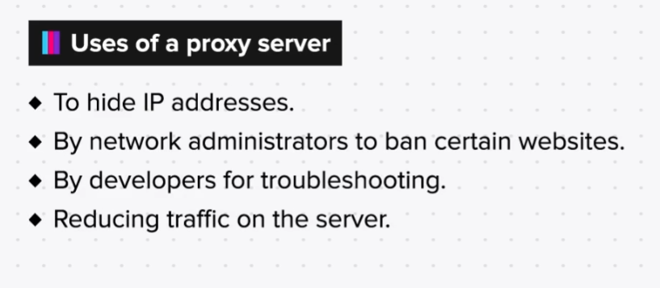

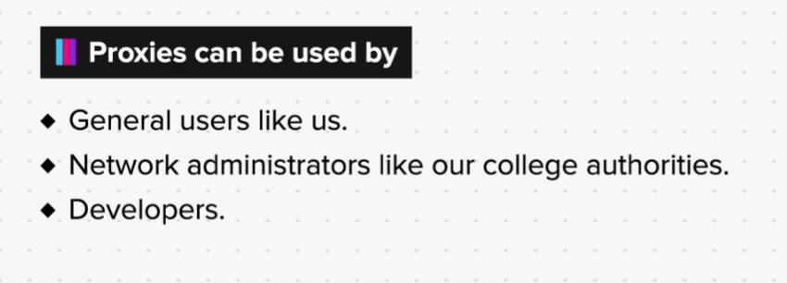

Uses of Proxy Servers - Summary

Uses of proxy servers:

General users:

1. Obscure their IP

2. Avoid surveillance

3. Bypass browsing restrictions

4. Access resources as from a different country

Developers:

1. Monitoring web traffic

2. Troubleshooting web applications

Network administrators:

1. To block malicious traffic

2. To balance overflowing traffic

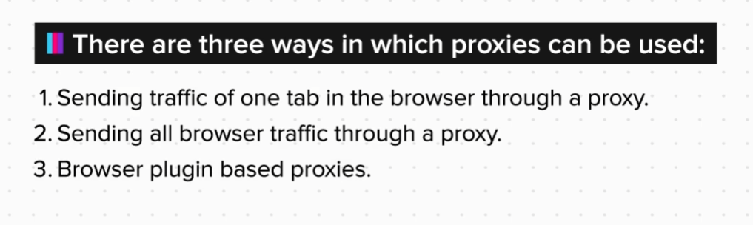

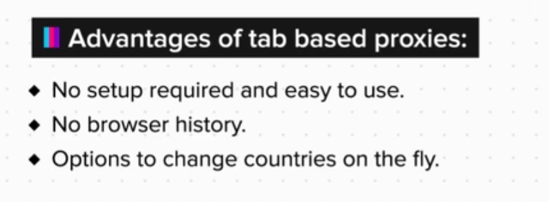

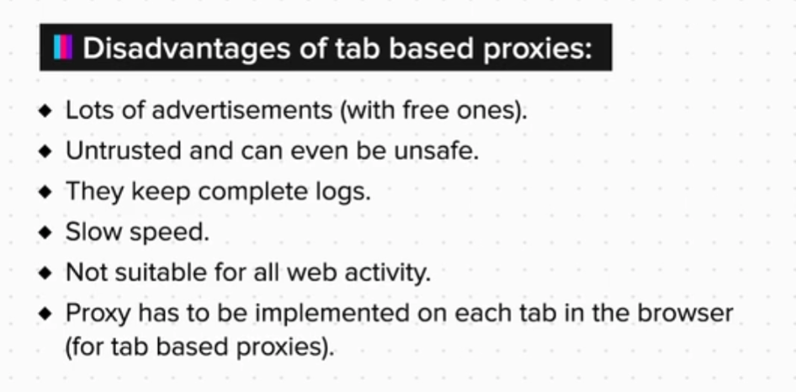

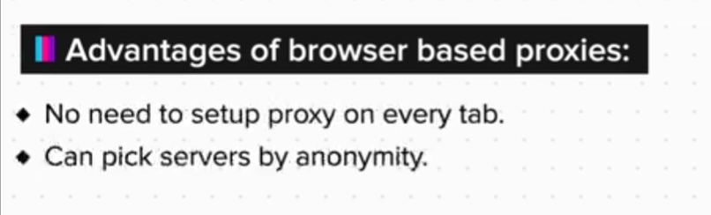

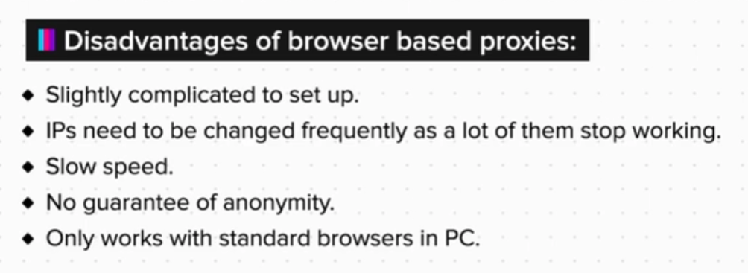

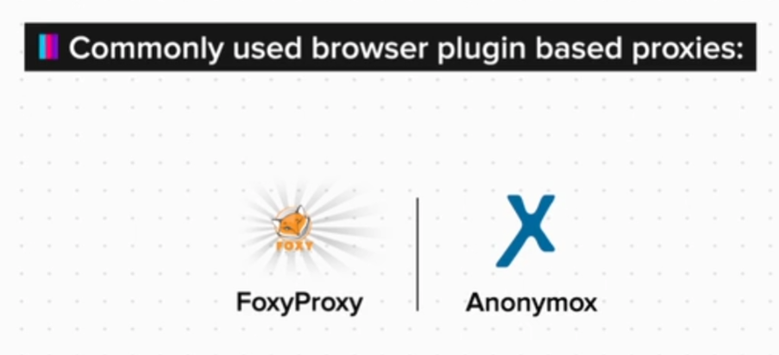

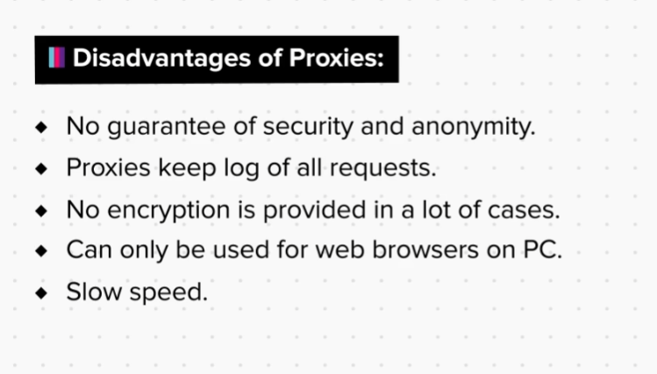

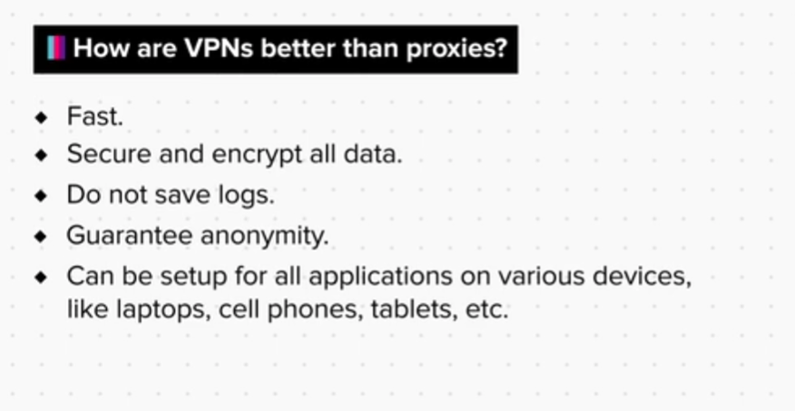

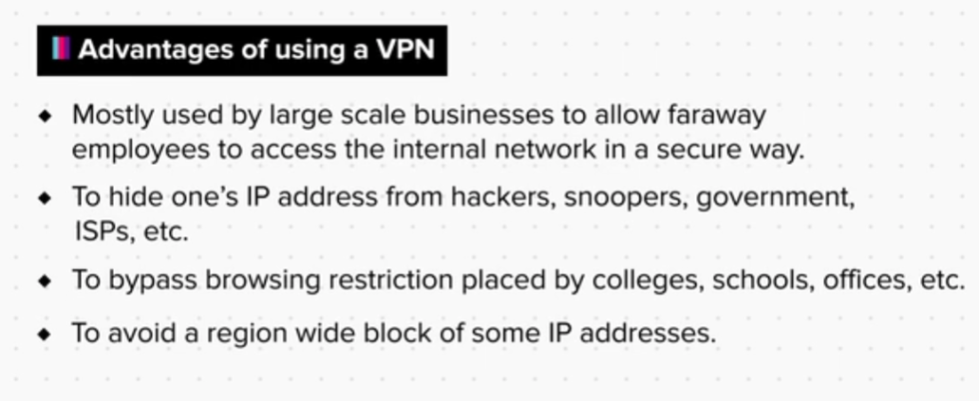

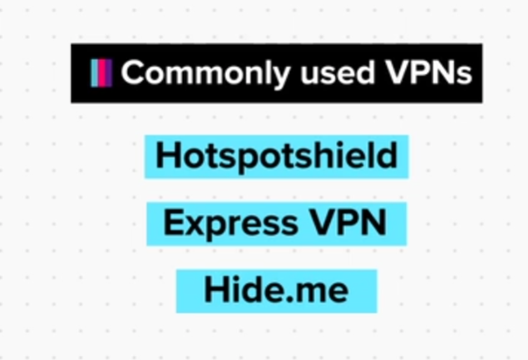

Resources

Links for ‘free web proxy’:

https://hide.me/en/proxy

https://www.croxyproxy.com/

https://kproxy.com/

Links for ‘public proxy server list’:

https://www.proxynova.com/proxy-server-list/

https://free-proxy-list.net/

How to configure proxy settings on firefox:

1. Open firefox.

2. Click ☰

3. Now click on the ‘options’ tab. For MAC users, this will be ‘preferences’.

4. Then click on ‘general’ tab.

5. Scroll down to the ‘network proxy’ section and click on settings.

6. Now check the ‘manual proxy configuration’ box and enter your proxy’s information.

7. Then click on okay, and your proxy settings are enabled.

Summary

Now that we have come to the end of this topic, you should be able to:

1. Set up proxies to bypass local web filters

2. Define a proxy and its uses

3. Configure a proxy server for your network connection

4. Set up VPNs to bypass local web filters

5. Define a VPN and its uses

6. Change the IP address and verify the change